CIBA Resolution Standard
Resolution standards are essential for calibrating and characterising the spatial resolution and scan dimensions of imaging systems. These standards enable precise determination of minimum resolvable distance, scan field dimensions, and beam spot size, particularly those employing charged particles like protons and electrons. For proton and electron beam imaging, requirements include high spatial resolution, precise beam spot size measurement, and low uncertainty in scan size calibration.
In 2013, Yao et al. [1] demonstrated via simulation that proton beam lithography can achieve resolution standards with remarkably vertical side walls (89.7°) in 1000 nm thick nickel, utilising poly-methyl methacrylate (PMMA) resist material. This feat is unattainable with electron beam lithography due to significant electron straggling in PMMA, resulting in large side wall gradients. In contrast, protons – 1836 times heavier than electrons – travel largely undeflected through the medium, enabling the creation of straight side walls.
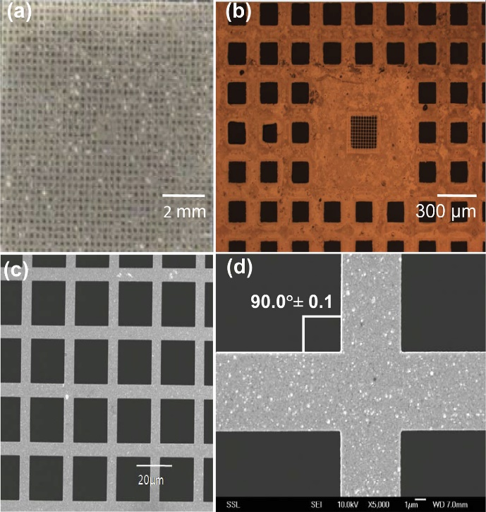
CIBA’s state-of-the-art accelerator drives our pioneering proton beam writing (PBW) system, which has yielded an array of achievements. These include significant biological applications [2] and the attainment of record-breaking spot sizes [3].
Utilising the same advanced proton beam writing (PBW) system, we can produce high-precision resolution standards featuring fine grids. A notable example is the nickel grid fabricated by Yao et al. [1], shown in Figure 1, which demonstrates the system’s exceptional capabilities.
Figure 1: Optical micrographs (a, b) and SEM images
(c, d) of fabricated nickel resolution standard
(Obtained from Yao et al. [1])
Further simulations reveal that our PBW system can achieve resolution standards with remarkably vertical side walls, reaching an unprecedented 89.8° - 89.9°. This exceeds the industry standard for straight side walls by an order of magnitude, enhancing the reliability and accuracy of characterisation results.

